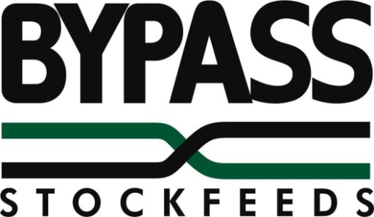
FEEDLOT CONCENTRATE

BYPASS FEEDLOT CONCENTRATE provides macro and micro ingredients for feed lotting sheep and cattle. This product gives good control of acidosis in sheep and cattle feedlots when used at recommended rates. Control of water belly in whether lambs is another feature.
BYPASS FEEDLOT CONCENTRATE can be ordered without the Ionophore, Bovatec 20CC included, but must be stated when ordering the product.

USAGE
50kg for each tonne of finished feed.
Add 2 x 25kg bags of concentrate AFTER adding grain and BEFORE adding roughage to mixer.
Allow to mix well before feeding out.

ANALYSIS
Each 50kg of Feedlot Concentrate provides the following for each tonne of finished feed:
Protein Meal | 1.75%
Lime | 1.0%
Salt | 0.5%
Vitamin & Mineral Premix | 0 – 5kg
Bovatec 20CC provides Lasalocid Sodium at rate of | 33mg/kg
Urea | 0.75%

PRECAUTIONS
Ensure Bovatec™ productivity enhancer for sheep and cattle is not fed to other animal species as toxicity may occur. Do not exceed the recommended dose rates.
DO NOT USE
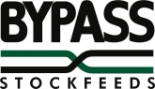
Bovatec in lactating ewes which are producing or may in the future produce milk that may be used or processed for human consumption.
CATTLE withholding period NIL
SHEEP Withholding period NIL
SHEEP export slaughter interval for Bovatec has not been established
INGREDIENTS
VEGETABLE PROTEIN MEALS, LIME, SALT, VITAMIN AND MINERAL PREMIX, BOVATEC 20CC™, ADVANCED RUMINATE BUFFERS, UREA AND VEGE OIL.
INCLUSION RATE 50KG/Tonne of Finished feed
ANALYSIS
DENSITY ........................................M3................................................. 0.68218
ME RUMINANTS .......................ME/Kg................................................ 5.0209
NPN PROTEIN EQUIVALENT ............................................................ 57.40%
CRUDE PROTEIN TOTAL ................................................................... 72.50%
CRUDE FAT ........................................................................................ 2.76%
CRUDE FIBRE .................................................................................... 4.3%
DRY MATTER ...................................................................................... 92.56%
ASH ..................................................................................................... 12.48%
CALCIUM .......................................................................................... 6.99%
UREA .................................................................................................... 20.00% MAX
PHOSPHOROUS ................................................................................. 0.43%
SALT ..................................................................................................... 20.00% MAX
ARGINNINE .......................................................................................... 1.47%
METHIONINE ....................................................................................... 0.37%
CYSINE ................................................................................................. 0.22%
LYSINE ............................................................................................... 0.66%
TRYPTOPANE ..................................................................................... 0.13%
ISOLEUCINE ........................................................................................ 0.48%
THREONINE ........................................................................................ 0.50%
MAGNESIUM ...................................................................................... 0.97%
ZINC .............................................Mg/Kg............................................. 48.7
IRON ..............................................Mg/Kg............................................. 216.85
SODIUM ..................................................................................................7.81%
CHLORINE ........................................................................................... 12.00%
SULPHUR ............................................................................................. 0.19%
POTASSIUM ......................................................................................... 0.62%

DOES NOT CONTAIN RESTRICTED ANIMAL MATERIAL

DO NOT FEED TO NON RUMINENT ANIMALS, AS THIS PRODUCT MAY BE TOXIC TO OTHER SPECIES.

SWEETBULK PTY LTD
ABN 83077109767

Coonabarabran Road, Baradine
Phone: 02 6843 1933
Email: glenda@sweetbulk.com
www.sweetbulk.com.au

